Think About What You Think

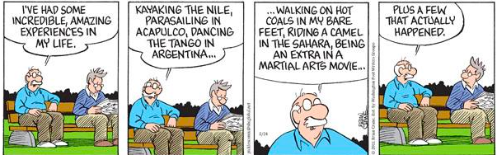 “The Power to redefine your life and purpose is in your hands, use it effectively like a wise person.” ~ Oche Otorkpa
Food for Thought...
Because older adults generally take more medications than younger people, the danger of an adverse interaction between alcohol and prescription drugs increases with age.
Think about this statement as you watch the video and complete the rest of the assignment. Make sure you follow "the instructions."

The Prompt
All ages can have problems with drugs and alcohol, including older adults. Many people think a substance use disorder only happens to teens and younger adults, but the truth is older adults misuse substances too, and substance misuse is a rapidly growing concern among seniors. Older adults misuse prescription drugs, over-the-counter medicines, use illegal drugs, drink too much alcohol, or mix alcohol and medicines. Substance use disorders in older adults, especially among retired seniors, is often overlooked, because older adults are more likely to drink or use drugs at home rather than in public. Signs of substance use disorder are similar to those found in health problems that many older adults have, such as depression and dementia. Additionally, since older adults may not have duties that are affected by substance use, such as going to school or work, oftentimes, substance use is hidden among seniors. Substance misuse among older adults is a growing problem.

The Instructions
- Watch the "Substance Abuse in the Elderly" video here.
- Referencing the video, your textbook, and other resources. discuss your role as the group leader (pgs. 318-319) of a group of older adults in an addictions treatment group.
- What are a couple of the strengths and limitations of a group leader with a group of substance abusing seniors?

Note:
- You must submit a post BEFORE you can see your classmates posts.
- Ideally, your response to your classmates should consist of a complete thought that contributes to the dialogue and furthers the discussion.
- There are no right or wrong responses, so share your knowledge, insights and thoughts freely,
- but please be respectful to one another as you explore and discuss your ideas.
- See the discussion rubric (in rubric link on the navigation bar) for grad

